**Chapter 1**

**Introduction**

* 1. **Overview**

Now a days, social distancing is main weapon in order to reduce the spread of “COVID-19”.our project deals with this concept .In densely populated countries like India, public crowded areas like bus stands, railway stations ,cinema halls ,malls ,hospitals and markets etc are more. In these areas, people will be gathered and it give a chance for spreading of virus .By maintaining social distancing, we can overcome this problem.

* 1. **Purpose**

The main idea of the project is to maintain SOCIAL DISTANCING between the people and alerting them if it is violated while stepping in & out , from & to buses ,rails ,malls and other commercial places.

In the project, we developed an software application [APP], through which will maintain social distance

Let’s us consider bus stand as example, we have seen alot of people will gathered during stepping in &out from the bus

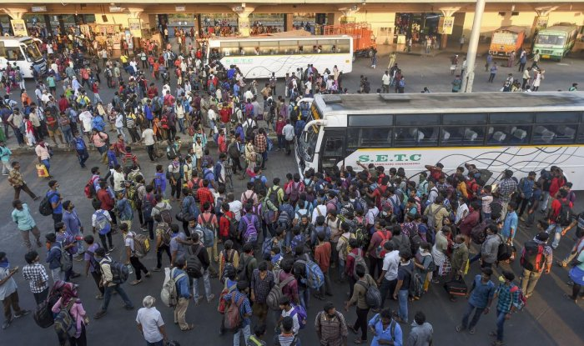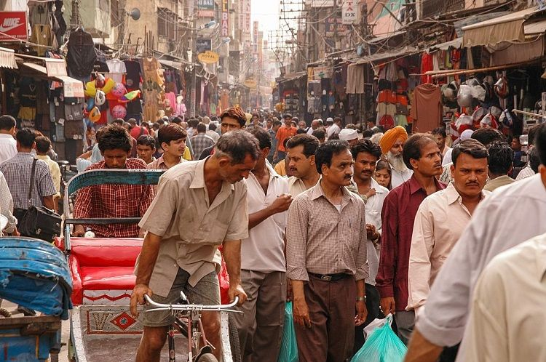

**Chapter 2**

**Literature Survey**

**2.1 Existing Problem**

Most of the people are violating the social distancing rule may be because of negligence, lack of information or sense or urgency.

In Arogya sethu app, alerting the person if the social distancing is violated is not available. And also some more useful features can be added to the current Arogya sethu app.

**2.2 Proposed Solution**

When people come closer to each other and having a distance less than 1 meter[as per requirement],the “APP” will trace the signal and send the alert messages to the people[mobile owners]for twice .With these alert messages, people will maintain the minimum prescribed distance.

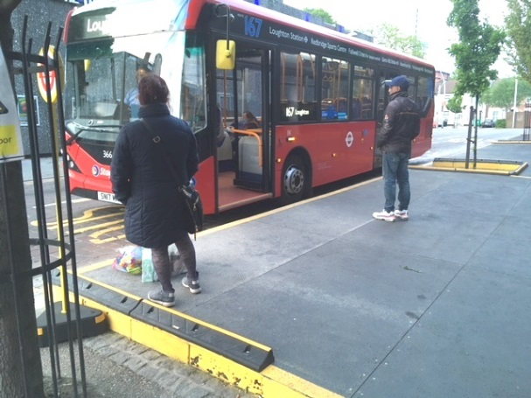

**Chapter 3**

**Theoretical Analysis**

**3.1 Block Diagram**

**3.2 Software Designing**

The proposed work is totally software based and it uses bluetooth connection among the devices and good network connection for identifying the location of the persons.

The proposed app is developed using Android Studio

**Chapter 4**

**Experimental Investigations**

In case the people[mobile owner]will ignore this alert message for twice ,by using his data we will insert a “penalty” as 500/- (say) rupees [according to effect of virus in that area].If people[mobile owner] ignore that message also a “police man” will approach the person and collect the money.

This “APP” is very useful to society ,when the government make it is mandatory to install in all phones

**Chapter 5**

**Flow Chart**

**Chapter 6**

**Results**

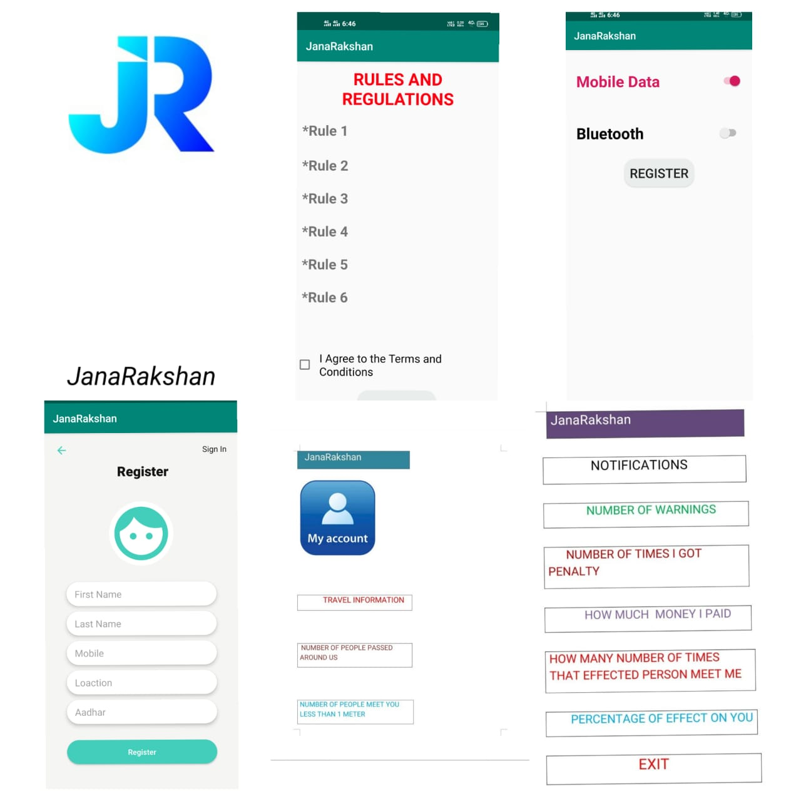

**Chapter 7**

**Advantages and Disadvantages**

**Advantages:**

In addition to this we will place the locations of the migrant workers & needy people who are locked down in different areas

Once the donor will log-in into this “APP”, he will get location of the needy peoples and the donor will supply the food & other materials

By this we can reduce the effort of the donor to find the needy people

This application helps us to maintain the data about how many visitors are regularly visiting that area

**Disadvantages:**

Good network connection is required.

**Chapter 8**

**Applications**

In this pandemic situation, this app helps almost all the human beings and allow them to be safe.

**Chapter 9**

**Conclusion**

Hence with the proposed work, people can maintain social distancing and know their responsibility towards oneself and others too.

**Chapter 10**

**Future Scope**

In addition to the alerting system, some other features like home remedies, allopathy guidance and precautionary actions can be included.

**Chapter 11**

**Bibliography**

* Arogya sethu app
* Android Studio
* Java programming language

Appendix

1. Source Code